Private

📌 Definition:
# Source: AI Source: Provided by: [Data Path: Persons Table -> ID Column: 1, Name_En Column: Motasem Essam] -> From: [Chatgpt (GPT‑5 Mini)] on [12/9/2025]
Private is an access modifier that restricts access to a variable or method so that it can be accessed only within the same class where it is declared.

🧠 Simple idea:
# Source: AI Source: Provided by: [Data Path: Persons Table -> ID Column: 1, Name_En Column: Motasem Essam] -> From: [Chatgpt (GPT‑5 Mini)] on [12/9/2025]
Private = “Only inside this class” 🔐

🔍 Key characteristics:
# Source: AI Source: Provided by: [Data Path: Persons Table -> ID Column: 1, Name_En Column: Motasem Essam] -> From: [Chatgpt (GPT‑5 Mini)] on [12/9/2025]
- ❌ Not accessible from outside the class
- 🔒 Highest level of data protection
- 🧩 Used to encapsulate data
- 🔄 Access is usually provided via getter and setter methods

📌 Example (Java):
# Source: AI Source: Provided by: [Data Path: Persons Table -> ID Column: 1, Name_En Column: Motasem Essam] -> From: [Chatgpt (GPT‑5 Mini)] on [12/9/2025]
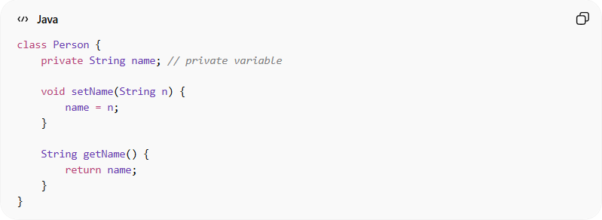
class Person {
private String name; // private variable

void setName(String n) {
name = n;
}

String getName() {
return name;
}
}

Usage:
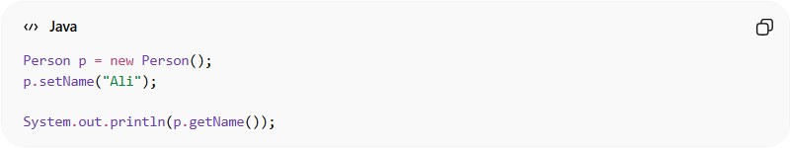
Person p = new Person();
p.setName("Ali");

System.out.println(p.getName());

❌ Direct access (not allowed):
# Source: AI Source: Provided by: [Data Path: Persons Table -> ID Column: 1, Name_En Column: Motasem Essam] -> From: [Chatgpt (GPT‑5 Mini)] on [12/9/2025]
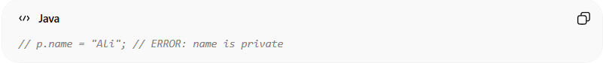
// p.name = "Ali"; // ERROR: name is private

🔄 Access inside the same class:
# Source: AI Source: Provided by: [Data Path: Persons Table -> ID Column: 1, Name_En Column: Motasem Essam] -> From: [Chatgpt (GPT‑5 Mini)] on [12/9/2025]
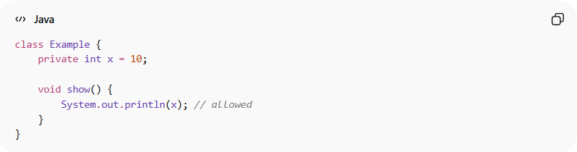
class Example {
private int x = 10;

void show() {
System.out.println(x); // allowed
}
}

🎯 Why private is important:
# Source: AI Source: Provided by: [Data Path: Persons Table -> ID Column: 1, Name_En Column: Motasem Essam] -> From: [Chatgpt (GPT‑5 Mini)] on [12/9/2025]
- 🔒 Protects data from direct modification
- 🧩 Enforces encapsulation
- ⚙️ Improves control over data access
- 🧠 Helps maintain data integrity

🎯 Summary:
# Source: AI Source: Provided by: [Data Path: Persons Table -> ID Column: 1, Name_En Column: Motasem Essam] -> From: [Chatgpt (GPT‑5 Mini)] on [12/9/2025]
Private access ensures that data is accessible only within the same class, providing the highest level of encapsulation and protection.

